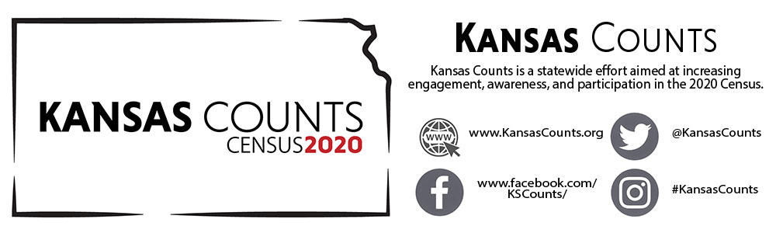
PRESS RELEASE – FOR IMMEDIATE RELEASE
How do I take the Census?
With the 2020 Census coming up on April 1, 2020, Americans are offered more ways to complete the census than ever before. As you know, the census occurs at the beginning of every decade and its primary goal is to count each person living in the United States. There are many benefits for the nation to know how many people live within its borders, such as how many representatives each state should have as well as congressional district boundaries. The U.S. government also uses the numbers to know how and where to distribute more than $675 billion across the country sending the federal funds into your sate and local communities. For example, the last census allowed Kansas to receive approximately $6 billion in federal funding based solely on the data collected 10 years ago. This year, the ways to take the census are more accessible than the past making it less of a challenge to count everyone.
What is different this year?
This year, for the first time, residents will be able to respond to the 2020 census questionnaire online or by phone. Starting in mid-March, people will begin receiving letters that include a unique number they will enter online. The letter also will have a phone number that people can call to respond to the questions in 13 languages. This gives everyone the opportunity to respond online before the formal response collection begins in April. Furthermore, you will receive a reminder letter mid-to-late March 2020 prompting you to complete the Census as soon as possible.
Can I still send in the paper form?
Yes, if you do not choose to complete your census by phone or online, a paper questionnaire will be mailed out mid-April to every household that has not responded to the census at that time. This questionnaire will have braille and large print versions available online to assist with completing the Census. If you forget to fill out your form or choose not to complete the census by phone or online, in May more than half-a-million census takers will visit all households having not yet responded and this will continue until July 31. There will also be census takers who are available to communicate in American Sign Language and additional languages.
The bottom line?
1. It's safe - no personal details are released for 72 years and all census workers must take a lifetime oath to protect personal information.
2. It's the law - Besides jury duty and paying taxes, participating in the Census is one of the few civic obligations you have as someone living in the United States.
3. You, your community, and your state will benefit - for things like education, health care, housing vouchers, and transportation infrastructure, access to this federal funding makes your participation critical.

Statistically, 95% of households will receive their census invitation in the mail. Almost 5% will receive their census invitation when a census taker drops it off (these are often homes with a PO Box or areas recently affected by natural disasters). Less than one percent of the population will be counted “in person” by a census taker instead of being invited to respond on their own (this generally occurs in very remote areas). To find out more about the 2020 Census and what is at stake for Kansas, visit www.KansasCounts.org or follow Kansas Counts on Facebook, Twitter or Instagram. If you have further concerns or believe there are components of accessibility not addressed, you are encouraged to visit www.2020census.gov.

https://www.census.gov/library/fact-sheets/2019/dec/2020-census-accessible.html
https://www.census.gov/library/fact-sheets/2019/dec/2020-census-accessible.html
https://www.census.gov/library/fact-sheets/2019/dec/2020-census-accessible.html
https://www.census.gov/library/fact-sheets/2019/dec/2020-invites-everyone.html

