Kansas Counts Messaging Guide
  - Prepared by the League of Kansas Municipalities
  - January 2020

The Kansas Counts Messaging Guide is compiled from research from national organizations (i.e., U.S. Census Bureau, National League of Cities, American Library Association, etc.) and other state CCC Communication tools. The purpose of the guide is to increase engagement, awareness, and participation in Kansas for the 2020 Census.
Make Kansas Count in 2020!

Kansas Counts Messaging
Kansas Counts is a statewide effort aimed at increasing awareness, and participation in the 2020 Census.
We all care about Kansas, our cities, our communities, and our homes. We can make a difference by participating in the 2020 Census. It only takes a few minutes, but the impact will be felt for years. In the spring of 2020, everyone in our country will get counted, so don’t miss out on your chance to make a difference.
Kansas Counts provides the opportunity to ensure you, your community, and the state of Kansas counts. Participation in the census helps:
- Create fair congressional representation for Kansans
- Obtain valuable information leaders can use to plan for your community’s future
- Determine resources for health, schools, transportation, and more.

Key Talking Points
- Census numbers are used to distribute over $6 billion in federal funds to Kansas every year.
- Every uncounted person costs the state of Kansas approximately $2,082 in federal funding.
- If 1% of Kansas is under counted in the 2020 Census, the state of Kansas could miss receiving approximately $603,990,400 in federal funding over a 10-year period. It is critical that you count, your community counts, and Kansas Counts by participating in the 2020 Census.
- Census data is used to determine federal, state, and local voting districts.
- Businesses and government agencies consider population trends when choosing places to locate, which in turn boosts economic growth.
- As it’s only a once-every-10-years process, it’s crucial to get the count right or states that are undercounted will be shortchanged for a decade.
- Government, businesses and other stakeholders use census data for infrastructure and transportation planning; emergency preparedness, disaster relief, education funding, health tracking and disease control, and a multitude of other things.

The 2020 Census & Local, County, and State Agencies

What Cities, Counties, and State Agencies Can do to Support Census Efforts & How Government Leaders Can Help
Collaborate with the Census Bureau and the Kansas Complete Count Committee (Kansas Counts)
- Identify a census point of contact to receive pertinent census information and Kansas-specific activities, events, and data.
- Use city-/county-/state-run social media and communications channels to amplify the Census Bureau’s and Kansas Counts’ communications campaign to maximize the self-response rate. This may also include the communication of more tailored messages that are customized for the population of your community or for specific Hard-to-Count populations.
- Share the Kansas Counts social media messages (https://kansascounts.org/social-media-messaging/) through your communication channels.
- Support the enumerator and address canvasser recruitment processes by promoting hiring efforts in your local city/county. These efforts help provide the Census Bureau with qualified applicants who are representative of the communities in which they will be working.
- Use census data in public materials to show their value. See examples on the Kansas Counts website (www.kansascounts.org) under Resources.
- Sign-up for the League of Kansas Municipalities weekly e-newsletter to stay up to date on census activities, events, resources as well as what can be done now. E-mail census@lkm.org to get on mailing list.
Integrate City, County, and State departments
- Use your own position to “get out the count.” Local and statewide elected and appointed officials are often the most trusted government representative residents hear from on a regular basis. Remind your constituents why participation in the 2020 Census is so important for themselves as well as their families, their neighborhoods, and for your municipality.
- Start an interdepartmental team and designate a lead coordinator from within existing staff to facility and organized and integrated outreach effort. Choose someone from whom agency leaders can answers to questions and guidance on efforts to support the 2020 Census.
- Leverage your office of Communications and Public Affairs to amplify Census Bureau and Kansas Counts messaging as well as counter potential disinformation. Your media presence and social media accounts may be especially trusted by members of your own community or with specific Hard-to-Count populations.

Additional Resources
Don’t forget to use resources from the Kansas Counts website. Many of these resources have been tailored for specific audiences. Consider using:
- 50 Ways Census Data is Used (p. 2) and the George Washington Institute Study (pp. 3-4) to demonstrate how and why the census is important. These resources are helpful when talking with those who don’t believe the census is important to them.
- City Infographics (https://kansascounts.org/government-resources/city-data/) or the City/County/Community Newsletter to demonstrate how the census impacts residents locally.
- Impact Funding infographics to target rural, higher education, k-12, and healthcare funding. These are available in English and Spanish.
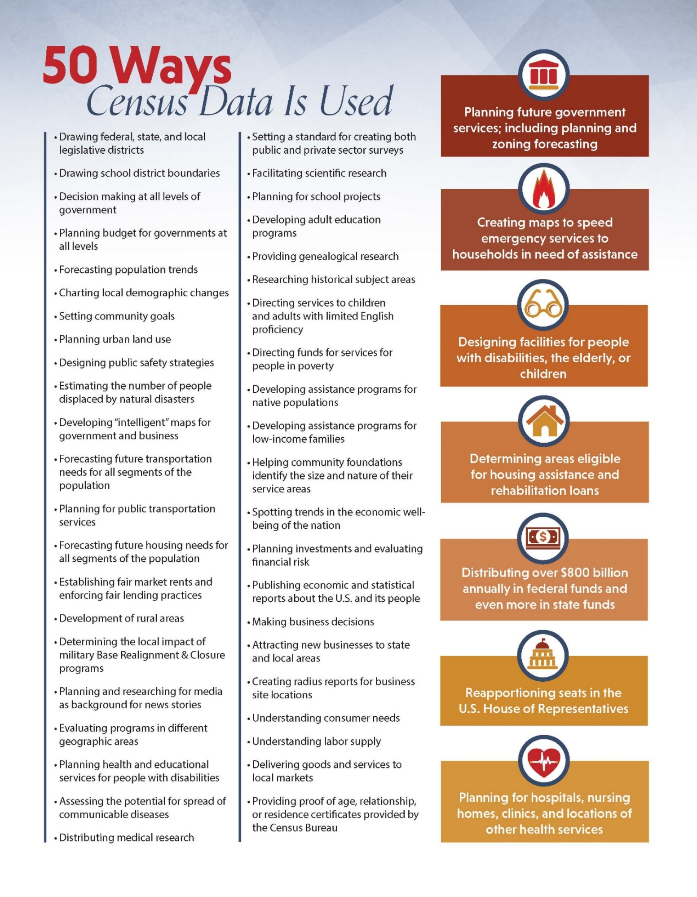

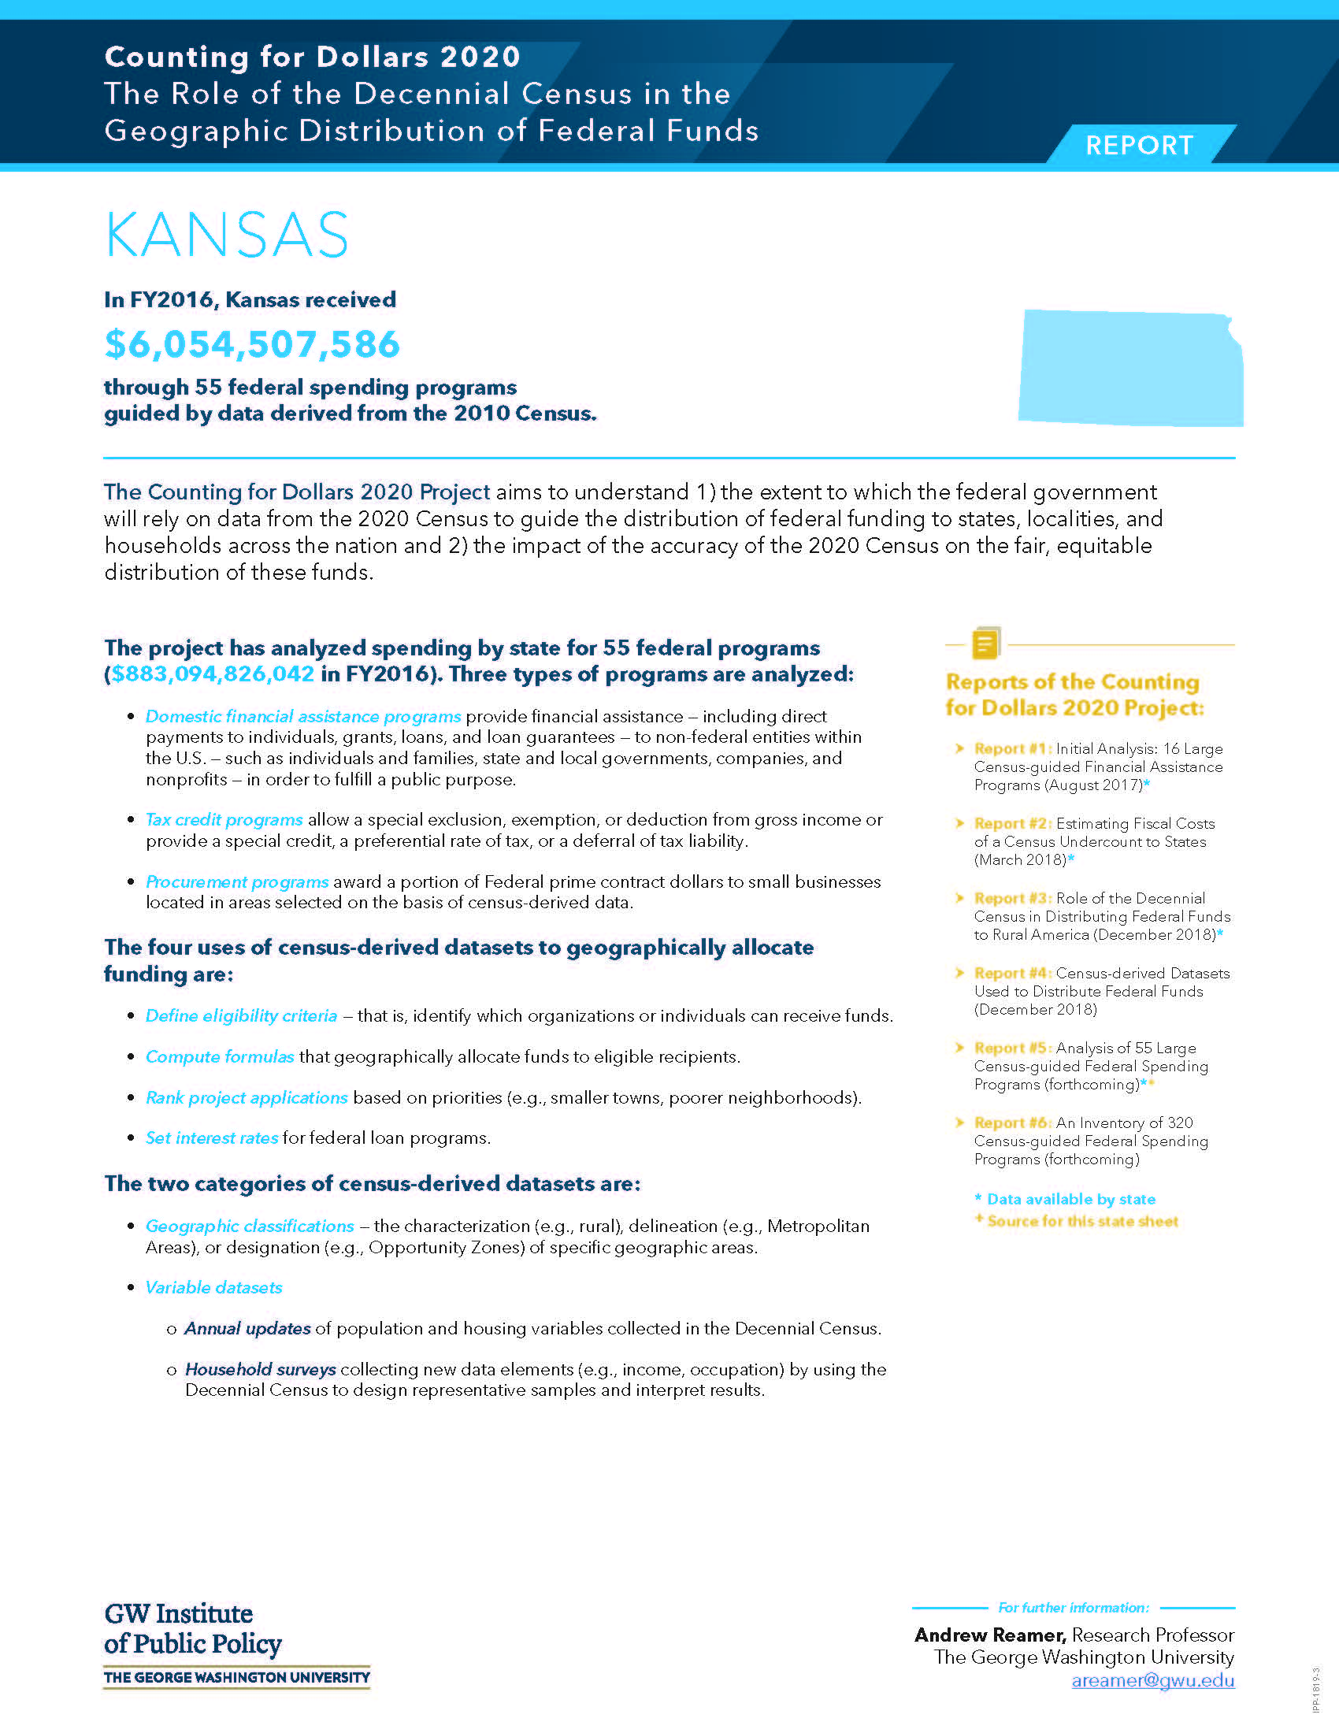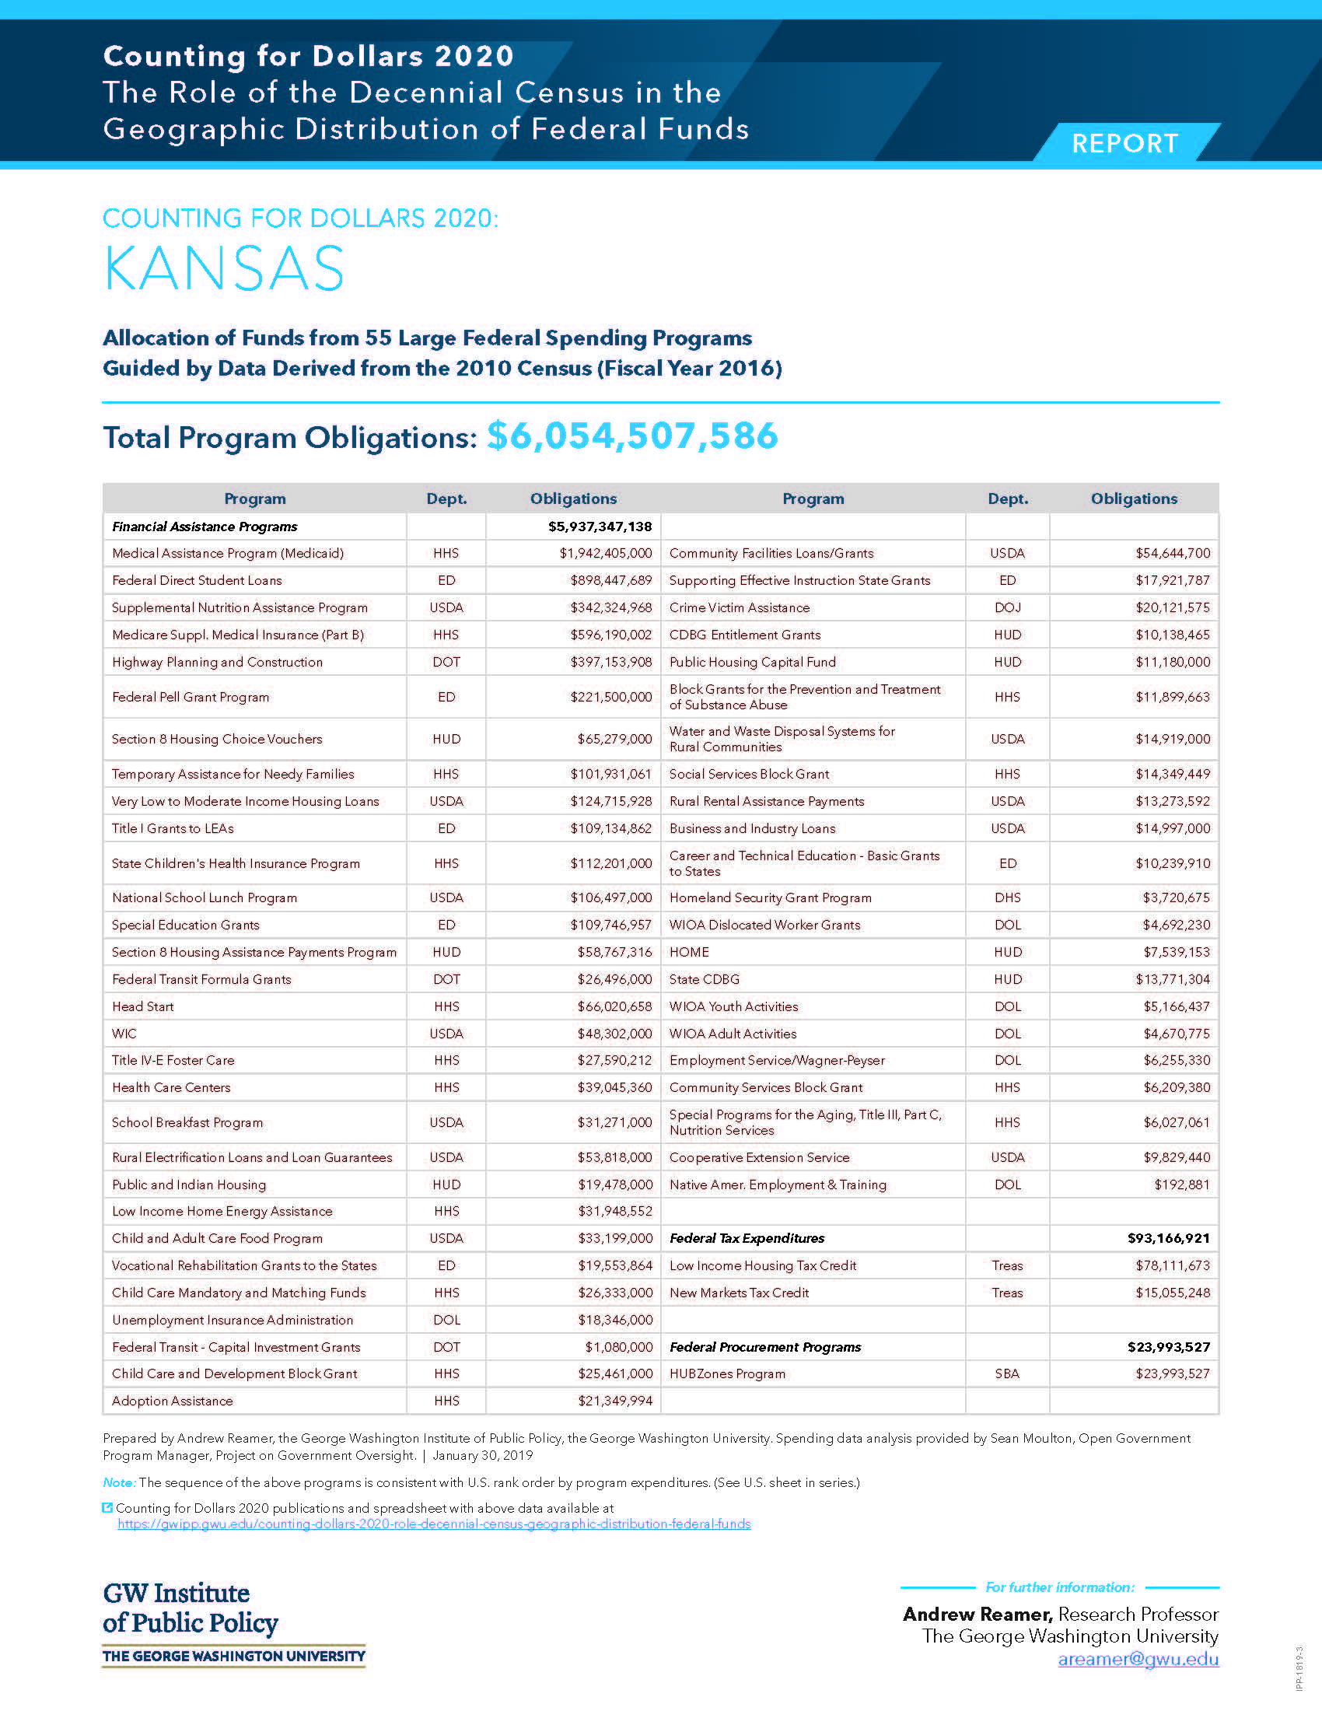U.S. Census Bureau Messaging
The following messages have been compiled from the U.S. Census Bureau’s Outreach Materials from handouts, flyers, and posters and modified with Kansas-specific messaging when possible. Link to website: https://2020census.gov/en/partners/outreach-materials.html?utm_campaign=20191212msprts1ccpupnl&utm_medium=email&utm_source=govdelivery#dd1142711330-co

2020 Census Short Messaging for State Complete Count Commissions (SCCCs) and Complete Count Committees (CCCs)
As a member of an SCCC or CCC, you’re a leader in your community. To engage your partners and the public, you can use and distribute short messages to promote the 2020 Census and its benefits to your state or community. Encourage partners to include a blurb on utility bills, lottery tickets, store receipts, or any other public-facing materials. You can use or tailor the examples below—some are educational, and some are motivational. Be creative!
Bills (utilities, doctors, clinics, etc.)
- Invest in your health. Participate in the 2020 Census. Visit www.kansascounts.org to learn more.
- Have a say in your services. Participate in the 2020 Census. Visit www.kansascounts.org to learn more.
- Pay your bills. Complete your census form. A few minutes will pay off for the next 10 years. Participate in the 2020 Census. Visit www.kansascounts.org to learn more.
- Shape your community. Participate in the 2020 Census. Visit www.kansascounts.org to learn more.
- Shape your parks, your health care, and your community. Participate in the 2020 Census. Visit www.kansascounts.org to learn more.
Store receipts
- Shape future business investments. Participate in the 2020 Census. Visit kansascounts.org to learn more.
- Shape our plans for future stores. Participate in the 2020 Census. Visit kansascounts.org to learn more.
- Support small businesses. Participate in the 2020 Census. Visit kansascounts.org to learn more.
Lottery tickets
- Shape your future. Participate in the 2020 Census. Visit kansascounts.org to learn more.
- Shape the distribution of $6,000,000,000 in Kansas’ annual public funding. Participate in the 2020 Census. Visit kansascounts.org to learn more.
- Shape your schools. Participate in the 2020 Census. Visit kansascounts.org to learn more.
- Shape the numbers. Participate in the 2020 Census. Visit kansascounts.org to learn more.
Miscellaneous (gas pumps, restaurant menus, etc.)
- Invest in our roads. Participate in the 2020 Census. Visit kansascounts.org to learn more.
- Shape your future and your family’s future. Participate in the 2020 Census. Visit kansascounts.org to learn more.

Responding to the Census Online

2020 Census and Confidentiality
Your responses to the 2020 Census are safe, secure, and protected by federal law. Your answers can only be used to produce statistics—they cannot be used against you in any way. By law, all responses to U.S. Census Bureau household and business surveys are kept completely confidential.
Respond to the 2020 Census to shape the future.
Responding to the census helps communities get the funding they need and helps businesses make data-driven decisions that grow the economy. Census data impact our daily lives, informing important decisions about funding for services and infrastructure in your community, including health care, senior centers, jobs, political representation, roads, schools, and businesses. More than $6 billion in federal funding flows back to Kansas and our local communities each year based on census data.
Your census responses are safe and secure.
The Census Bureau is required by law to protect any personal information we collect and keep it strictly confidential. The Census Bureau can only use your answers to produce statistics. In fact, every Census Bureau employee takes an oath to protect your personal information for life. Your answers cannot be used for law enforcement purposes or to determine your personal eligibility for government benefits.
By law, your responses cannot be used against you.
By law, your census responses cannot be used against you by any government agency or court in any way—not by the Federal Bureau of Investigation (FBI), not by the Central Intelligence Agency (CIA), not by the Department of Homeland Security (DHS), and not by U.S. Immigration and Customs Enforcement (ICE). The law requires the Census Bureau to keep your information confidential and use your responses only to produce statistics.
The law is clear—no personal information can be shared.
Under Title 13 of the U.S. Code, the Census Bureau cannot release any identifiable information about individuals, households, or businesses, even to law enforcement agencies.
The law states that the information collected may only be used for statistical purposes and no other purpose.
To support historical research, Title 44 of the U.S. Code allows the National Archives and Records Administration to release census records only after 72 years.
All Census Bureau staff take a lifetime oath to protect your personal information, and any violation comes with a penalty of up to $250,000 and/or up to 5 years in prison.

Sample messages for partners.
Newsletters, blogs, social media, and emails are great ways to share information with your audience. Below are a few sample messages that you can drop into your communications to tell your community about the importance of the 2020 Census. These messages are intended to inform the audience about the census and should be used prior to April 1, 2020.
- General messages. The 2020 Census is fast approaching. Data collected in the census will inform the distribution of more than $6 billion in federal funds to Kansas and our communities each year for things like infrastructure, health care, and food assistance. It’s important that we all respond to shape the future of our communities. Learn more at kansascounts.org.
- Be sure to count everyone who lives in your home on your 2020 Census form. This includes babies and young children, who are often missed in the census. Not counting newborn babies and children impacts support for programs such as children’s health insurance, hospitals, childcare, food assistance, schools, and early childhood development. It is important to count all the babies and children in your home, even if they aren’t related to you or are only staying with you temporarily. Learn more at kansascounts.org.
- Your responses to the 2020 Census are safe, secure, and protected by federal law. Your answers can only be used to produce statistics. They cannot be used against you by any government agency or court in any way—not by the FBI, DHS, or ICE. Learn more at kansascounts.org.
- Message for renters. Beginning in mid-March 2020, you can respond to the census online, by phone, or by mail. Be sure to count everyone living or staying in your home, including newborn babies and young children, even if they aren’t related to you or are only staying with you temporarily. No matter how you respond, your personal information is confidential, is protected by law, and can never be used to identify you. It can never be shared with law enforcement agencies or your property manager. Learn more at 2020CENSUS.GOV. For more information, visit: 2020CENSUS.GOV Messages for college students. The 2020 Census will influence community funding and congressional representation. Responding to the census is your chance to impact programs like Pell Grants, health care services, food assistance, and more for the next decade. Shape the future by responding to the 2020 Census. Learn more at kansascounts.org.
- If you live in off-campus housing that is not owned, leased, or managed by your college or university, you can respond online, by phone, or by mail beginning in mid-March 2020. You should count yourself at your off-campus address, even if you stay somewhere else during school breaks. Learn more at kansascounts.org.
- If you live in on-campus student housing or in another student housing facility that is owned, leased, or managed by your college or university, census takers will work with student housing officials to ensure that you are counted. You may be asked to complete an individual census form. Learn more at kansascounts.org.
- Message for group housing residents. If you live in a group facility, like military barracks or shelters, census takers will work with a representative from your building to make sure you are counted where you live and sleep most of the time. They may ask you to complete an individual census form. Learn more at kansascounts.org.
- Message for faith-based audiences. Your responses to the 2020 Census are safe, secure, and protected by federal law. Your answers can only be used to produce statistics, which help determine federal funding for things like food assistance, health care services, and Pell Grants. They cannot be used against you by any government agency or court in any way—not by the FBI, DHS, or ICE. The U.S. Census Bureau asks about race and ethnicity in the decennial census, but it does not collect information about religious affiliation. U.S. law prohibits the Census Bureau from requiring anyone to disclose their religious affiliation. Learn more at kansascounts.org.

Messaging for Specific Hard-to-Count Populations (HTC) and Key Stakeholders

Accessibility of the 2020 Census
The 2020 Census is accessible for everyone. Beginning in mid-March 2020, you can respond to the census by answering a handful of questions online, by phone, or by mail.
- The online questionnaire is accessible to people with a wide range of disabilities. If you prefer to respond by mail but do not receive a questionnaire in your first mailing from the U.S. Census Bureau, you can wait for the fourth mailing, in mid-April 2020, which will include a questionnaire.
- If you have blindness or low vision, you can print a guide to the questionnaire in braille or large print from 2020CENSUS.GOV.
- If you have deafness or a hearing loss, you can:
  - Respond to the census using telephone devices for hearing impaired.
  - Access video guides to the questionnaire in American Sign Language on 2020CENSUS.GOV.
  - View online videos and webcasts with closed or open captioning.
  - Request a visit from a census taker who uses American Sign Language.
- 2020CENSUS.GOV is a 508-compliant website accessible to people with blindness or low vision, deafness or hearing loss, learning disabilities, cognitive limitations, limited movement, photosensitivity, and various combinations of these.
- From May – July 2020, census takers will visit households that have not yet responded. A census taker can assist if you need help completing your form.
- Responding helps influence funding for your community. The 2020 Census will influence community funding and congressional representation for the next decade. Information collected in the census will inform the allocation of more than $6 billion in federal funds for Kansas each year. That includes money for things like:

  - Public transportation
  - Libraries
  - Education programs
  - Supplemental Nutrition Assistance Program (SNAP)
  - Medicare and Medicaid
  - Temporary Assistance for Needy Families

American Indians
A complete and accurate count of American Indians and Alaska Natives throughout the United States contributes to better planning and decision-making for Indian Country, and it helps determine how billions of dollars in federal funding is distributed to communities and tribes for programs and grants. Your participation in the census builds on our communities’ progress and helps shape our future for generations to come.

Asian American
The 2020 Census shapes your future.
The census comes around once every 10 years and is a count of everyone living in the country. Your response will inform how more than $6 billion in federal funding each year is spent on critical services, including education, health care, senior centers, and public transportation in Kansas. Responding is important for you, your family, and your community.
Census data impacts funding for things like:

- Schools
- Head Start
- Language assistance programs
- Other educational programs
- Career and technical education grants
- Libraries
- Community centers
- Parks, playgrounds, and recreational facilities
- Emergency services
- Medicare
- Health clinics
- New roads

Black/African American
Responding is important.
You can shape the future for yourself, your family, and your community for the next 10 years. Data collected in the 2020 Census will inform the distribution of more than $6 billion in federal funds to Kansas and our communities each year. Businesses, community leaders, and local governments use census data to create jobs, ensure public safety preparedness, and support community initiatives.
Results of the census impact funding for things like:

- Schools and education
- Health care facilities
- Housing assistance
- Public transportation
- Child and adult food assistance programs
- Assistance for people transitioning out of homelessness
- Career and technical education grants
- Medicare Part B

Census data impacts funding for things like:

- Head Start
- School meal programs
- Adult education grants
- Historically Black colleges and universities
- Public transportation and roads
- Housing assistance
- Emergency services
- Medicare
- Health clinics
- Supplemental Nutrition Assistance Program
- Preventive health services

College Students
On campus or off, it’s easy to shape your future. Every 10 years, the United States counts everyone living in the country, including college students like you. Your response to the 2020 Census will help make sure communities across the nation are accurately funded and represented for the next decade. Responding is easy.
Students who do NOT live in university-owned or managed housing. If you live in off-campus housing that is not owned or managed by your college or university, make sure you and your roommates submit only one response that includes everyone who lives there. Beginning in mid-March 2020, you can respond to the census online, by phone, or by mail. Even if you spend time somewhere else during school breaks, you should be counted at your off-campus address.
Students who live in university-owned or managed housing. If you live in on-campus housing—like a residence hall, dorm, or apartment—or in off-campus housing that is owned or managed by your college or university, the Census Bureau will work with your college or university to count you in one of the following ways:
- A census taker may drop off census forms with your building contact person, who will distribute one to each resident.
- A census taker may interview each resident in your building to complete the census form.
- A representative from your dorm or building may complete the census form on behalf of all residents.
If you are an international student, the same rules apply both on and off campus.

- If you live in off-campus housing that is not owned, leased, or managed by your college or university, such as a private house that you share with other students or a privately owned apartment, you can respond online, by phone, or by mail beginning in mid-March 2020. You should count yourself at your off-campus address, even if you spend time somewhere else during school breaks.
- If you live in on-campus student housing like residence halls, off-campus residence halls, or other student housing facilities that are owned, leased, or managed by your college or university, U.S. Census Bureau employees will work with representatives from your building to ensure that you are counted. You may be asked to complete an individual census form.
- If you are an international student, the same rules apply.
Responding is important. The 2020 Census will influence community funding and congressional representation. Information collected in the census will inform the allocation of more than $6 billion in federal funds for Kansas communities each year. That includes money for things like:

- Federal Pell Grants
- Adult education grants
- Agriculture, science, and engineering education
- Student wellness programs
- The Medical Assistance Program
- Community mental health services

Group Housing
Everyone counts in group housing.
No matter where you live, it is important that you are counted in the 2020 Census. Information collected in the census will help determine funding for vital community resources, congressional representation, and more.
You should be counted where you live and sleep most of the time. If you live in a group facility, like a dorm, military barracks, or shelter, U.S. Census Bureau employees will work with a representative from your building to make sure you are counted. You may be asked to complete an individual census form.
Your building may include you in its count.
Those living in most group facilities, including college dorms, nursing homes, psychiatric and other medical facilities, correctional facilities, group homes, and some shelters, will be counted in one of the following ways:
- A representative from your building will electronically submit your information to the Census Bureau. It will be encrypted to make sure it remains confidential.
- A Census Bureau employee will interview a representative from your building in person.
- A Census Bureau employee will drop off paper census forms for residents to complete and pick them up later.
- At some medical and correctional facilities, a representative from your building will work as a census taker to collect information from the facility’s residents.
A place where you receive services may include you in its count.
Census Bureau employees will work with transitional shelters, meal centers, and other places where people receive services to make sure everyone is counted. If you are staying in one of these places, or are experiencing homelessness and receive services there, you may be counted through an in-person interview with a census taker. A representative from the service’s facility may submit a roster to the Census Bureau to make sure nobody is missed.
The military may include you in its count.
If you live in a military barracks or dormitory, a representative will count you as part of the facility. If you are assigned to a military vessel with a home port outside of the United States, you will be counted using data from the U.S. Department of Defense. For more information about how the census counts active duty military and their families, visit 2020CENSUS.GOV and search military.
To confirm how your building will be counted, check with your building supervisor or manager.

Hispanic
Everyone living in your home counts.
The census counts every person living in the United States regardless of their country of origin or immigration status. This includes children and newborn babies, grandparents, friends, nonrelatives, and everyone who is living or staying with you as of April 1, 2020.
The 2020 Census is safe and confidential.
Responses to the census are safe and confidential. Your information is protected by law and cannot be shared with other law enforcement agencies—not the FBI, ICE, or even local police.
The 2020 Census is easy and convenient.
The census is available in many languages, including Spanish. You can respond online, by phone, or by mail.
The 2020 Census is important for our community.
Your answers to the 2020 Census will impact funding decisions for the next 10 years for important local services in our communities, including:

- Schools
- Health clinics
- After-school programs
- Public transportation
- Roads
- School lunch programs
- Playgrounds
- Community centers for seniors

Nada que temer, mucho que ganar.
Cuando participas en el censo, tus respuestas están protegidas y nadie puede compartir tu información personal con ninguna entidad del gobierno, esto incluye al ICE, el FBI o la policía. Cada 10 años, los datos del censo ayudan a determinar cómo se distribuyen los fondos federales en nuestras comunidades para que se beneficien con:

- Más programas educativos
- Clínicas de salud
- Centros recreativos
- Programas de almuerzos escolares
- Centros comunitarios para adultos mayores

El censo es nuestra oportunidad de contribuir para que haya un mejor futuro en nuestra comunidad.

Homeless
You count, no matter where you live.
Every 10 years, the United States counts everyone who lives in the country. Your participation in the 2020 Census will help communities like yours get the funding they need to provide housing and food assistance and other vital services.
Responding is important.
The 2020 Census will influence funding for community services for the next 10 years. Data from the census helps determine where over $6 billion is spent each year in Kansas and our communities. That includes money for things like:

- Supplemental Nutrition Assistance Program (SNAP)
- Community centers
- Libraries
- Housing assistance
- Medicare
- Employment resources

There are many ways to respond.
Beginning in mid-March 2020, you can respond to the census. Many libraries and community centers will have public computers available for you to respond online at 2020CENSUS.GOV. You can also respond by phone. Census takers will work with shelters, meal centers, group homes, and other places where you may receive services to make sure everyone is counted, including babies and young children. If you or your children are staying with a relative or friend, make sure they include you on their census response form.

Immigrant/Foreign-Born
The Census Counts Everyone Living in the United States
What is the U.S. Census?
Since 1790, every 10 years, we count everyone who lives in the country, as required by the U.S. Constitution. We collect basic information, such as age, sex, and race, for every person in every household. Starting in the spring of 2020, everyone will be asked to complete the 2020 Census online, by phone, or by mail.
Why is the 2020 Census important for you?
The 2020 Census is much more than just a head count. It also gives you an opportunity to shape the future for yourself, your family, and your community. Data collected through the census:
- Provides a picture of our nation and its communities and helps determine where to build new schools, hospitals, and businesses.
- Informs the allocation of more than $6 billion in federal funding to Kansas and our communities each year for programs that support education, housing, health facilities, transportation, emergency services, food assistance, and more.
- Determines how many representatives each state will have in Congress.
Census responses also help your community in other ways. For example, the information can be used to help protect civil rights laws and determine when services should be provided in other languages. The information can also attract businesses that cater to communities with diverse populations. It can help employers better understand the local talent pool and provide new job opportunities.
Who is counted in the 2020 Census?
The 2020 Census counts every person living in the United States on April 1—no matter where they are from, why they are here in the United States, and whether or not they are documented. This includes temporary workers, international students, and workers on assignment from overseas.
Will my information be kept safe?
Yes. The U.S. Census Bureau is bound by law to protect the privacy and confidentiality of everyone who responds to the census. These protections ensure the personal information you provide cannot be used against you in any way.
- The Census Bureau combines your responses with other responses to produce statistical summaries. It is against the law for the Census Bureau to disclose or publish any identifiable information about an individual or household. The penalty for violating this law is severe: a fine of up to $250,000, imprisonment for up to 5 years, or both.
- By law, your personal information cannot be used against you or against anyone else by any government agency or court—and it can’t be accessed by the police department, DHS, ICE, FBI, or CIA.
- The Census Bureau encrypts all responses submitted online and stored in its computers.

LGBTQ+
Everyone Counts
Every 10 years, the United States counts everyone living in the country on April 1, regardless of their nationality or sexual orientation. On the 2020 Census, you’ll have the option to identify a relationship as same sex on your response.
Your responses benefit the LGBTQ+ community.
A complete count will ensure the accuracy of your state’s representation in the U.S. House of Representatives and inform the distribution of over $6 billion annually in federal funding for community programs across Kansas. That includes programs like:

- Community Development Block Grants
- HIV Emergency Relief Project Grants
- Housing assistance
- Adoption assistance
- Career and technical education grants
- Child and Adult Care Food Program
- Projects for Assistance in Transition from Homelessness

Your responses are a valuable resource.
Your responses will provide the most reliable data to date on the number of same-sex marriages and same-sex cohabiting partners in the United States—vital information for advocates, policymakers, and researchers working on LGBTQ+ issues.
Your responses are safe.
Your responses to the 2020 Census are confidential and protected by law. Personal information is never shared with any other government agencies or law enforcement.
Get counted.
In early 2020, every household in America will receive a notice to complete the census online, by phone, or by mail.

Middle Eastern and North African
Our differences count.
Shaping the future of our community starts with the 2020 Census.
Easy
Respond online, by phone, or by mail. The online form is available in many languages, including Arabic.
Safe
Title 13 of the U.S. Code requires that your personal information be kept confidential. Your information cannot be shared with any law enforcement or government agency.
Important
Responses to the census will inform how more than $6 billion in public funding in Kansas flows to things like community services, health clinics, after-school programs, college and university grants, and programs that support minority-owned businesses.
Census data impacts funding for things like:

- After-school programs
- School meal programs
- English as a second language programs
- Public transportation and roads
- Housing assistance
- Emergency services › Medicare
- Health clinics
- Supplemental Nutrition Assistance Program
- Preventive health services
- College and university grants

Migrant Workers
Tu trabajo cuenta mucho y tú también.
No importa si solo viniste a los Estados Unidos a trabajar, tú también cuentas en el Censo del 2020. Al ser contado, ayudas a que nuestras comunidades se beneficien con mejores escuelas, transporte público y más clínicas de salud.
Puedes llenar el censo por internet, por teléfono o por correo y estará disponible en español.
Además, tus respuestas son estrictamente confidenciales y por ley, tu información personal no se puede compartir con agencias de gobierno como ICE, el FBI o la policía.
El censo cuenta a todos para que a todos nos vaya mejor.

- Programas educativos
- Programas de almuerzos escolares
- Programas de asistencia alimentaria
- Transporte público
- Clínicas de salud
- Puentes y carreteras
- Centros para adultos mayores
- Y mucho más

Military
Serve your country and your community.
As a member of the military, you and your family understand what it means to serve your country. You can provide another great service to your country and community by responding to the 2020 Census.
Foundation of Our Democracy
Every 10 years, the federal government counts everyone who lives in the United States. The decennial count is required by the Constitution and is a foundation of our democracy, because the population of each state determines the number of representatives it has in the U.S. House of Representatives.
Service to Your Community
Responses to the 2020 Census will drive decisions on how more than $6 billion in federal funds is distributed in Kansas each year for the next 10 years. That’s money that is used for education, housing, health care, emergency services like firefighting, and more.
Get Counted!
The 2020 Census begins in early 2020. Most military households are responsible for submitting their own 2020 Census form online, by phone, or by mail. You are counted with your household if that is where you live. But, active duty service members may face some special circumstances. Here’s how to be counted if:
- You are stationed or living in the United States, and you are NOT deployed elsewhere. Unless you are staying in military barracks or dormitories on April 1, 2020, you should fill out a 2020 Census form for your household and list everyone who lives there.
- You are staying in military barracks or dormitories on April 1, 2020. Census Bureau employees will work with a representative of the building to ensure you are counted. They may or may not ask you to complete an individual census form. If your family is living off base, they should fill out a 2020 Census form for that household, but they should not list you on that form.
- You are stationed or deployed outside the United States, or you are assigned to a military vessel with a homeport outside the United States, as of April 1, 2020. The Census Bureau will use data from the U.S. Department of Defense to count you (and any family members that are living with you overseas). If your family is living in the United States, they should fill out a 2020 Census form for that household, but they should not list you on that form.
Note: “Outside the United States” includes any place that is outside the 50 States and D.C.

Your community is counting on you.
Make sure you are counted in the 2020 Census. A census is conducted every 10 years to count everyone living in the United States, including babies and young children. Responses help determine how billions of dollars in federal funding are distributed to states, counties, and local communities.
Some circumstances, like deployment, are unique to active duty service members and their families when it comes to completing the census. Make sure you know how to get counted correctly so you can support your community!
For information on how the census counts active duty military and their families, visit 2020CENSUS.GOV and search military.
Census data impacts funding for things like:

- Education
- Housing
- Emergency services
- Libraries
- Supplemental Nutrition Assistance Program
- Preventative health services
- Medical facilities
- School meal programs
- Parks
- Public transportation and roads

Multigenerational Households
Shape the future for your family.
Every 10 years, the census counts everyone living in the United States. It is important to count every person living in your home to make sure your community and others across the nation are accurately funded and represented for the next decade.
Count everyone, from grandpa to the new baby.
No matter who lives in your home, be sure to count them all in the 2020 Census. This includes grandparents, young children, foster children, and nonrelatives who are living with you. Information collected in the census will inform the allocation of more than $6 billion in federal funding in Kansas each year. That includes money for things like:

- First responders
- School meals
- Medicare and Medicaid
- Adoption assistance
- Food assistance programs
- Libraries and community centers

Your response is safe.
Your personal information is kept confidential by law.
Your responses can be used only for statistical purposes. They cannot be used for law enforcement purposes or to determine your personal eligibility for government benefits.
Your family can help you respond.
The online census form is available in English and 12 additional languages. If you do not speak one of those languages, someone else in your home can complete the form for everyone in your home. If the adults in your home do not speak one of these languages, someone can translate for you. This includes a child in your home or a friend.

Native Hawaiians and Pacific Islanders
As Pacific Islanders...
... living in the United States, we have the right to be counted in the 2020 Census.
The U.S. census is a population count that happens every 10 years. Everyone in your home should be counted, including newborn babies and children of all ages.
The census informs how billions of dollars in public funding are spent each year.
Your responses to the census are confidential.
You can respond online, by phone, or by mail.
Shape our future. Start by responding to the 2020 Census.
Census data impacts funding for resources like:

- Head Start
- School meal programs
- Adult education programs
- Public transportation and roads
- Housing assistance
- Emergency assistance
- Medicare
- Health clinics
- Supplemental Nutrition Assistance Program
- Preventative health services

Newborns
Remember to count !
Congratulations on welcoming your new bundle of joy! If your baby was born on or before April 1, 2020, remember to count them on the 2020 Census.
The census informs decisions about funding for things like health insurance, hospitals, child care, food assistance, schools, and early childhood education for the next 10 years—basically an entire childhood!
Beginning in mid-March 2020, you can respond to the census online, by phone, or by mail. Don’t miss this opportunity to shape the future for your baby and your community!

Older Audiences
The census counts every generation.
Every 10 years, the United States counts everyone who lives in the country, from newborn babies to the oldest among us. It is important for everyone to complete the 2020 Census so that communities like yours can be accurately funded and represented.
Responding is important.
The 2020 Census will influence community funding and congressional representation for the next decade. Information collected in the census will inform the allocation of more than $6 billion in federal funds for Kansas and our communities each year. That includes money for things like:

- First responders
- Medicare Part B
- Supportive Housing for the Elderly Program
- Libraries and community centers
- Supplemental Nutrition Assistance Program (SNAP)
- Senior Community Service Employment Program

Responding is easy.
Beginning in mid-March 2020, you can respond to the census online, by phone, or by mail. Choose the option that is most comfortable for you. Large-print guides to the questionnaire are available upon request. From May – July 2020, census takers will visit households that have not yet responded. A census taker can assist if you need help completing your form.

Renters
Counting everyone in your household can shape your future.
Every 10 years, the United States counts everyone living in the country on April 1, regardless of their nationality or living situation. This includes renters.
To ensure an accurate count, remember to:
- Count every person living or staying in your home.
- Respond at the address where you were living or staying on April 1, 2020.
What’s in it for me?
The 2020 Census is an opportunity to create a better future for our communities and the next generation by providing an up-to-date count of our population. The data collected will help determine how over $6 billion in federal funding is distributed in Kansas each year for things like housing assistance, infrastructure, and public transportation.

Rural
Every town is an important part of the American story.
Make sure your town’s story is told by responding to the 2020 Census—the count of everyone living in the United States. When you do, you’ll also help your town get the most out of the American dream.
Responding Is Important for Your Community
Census responses provide data that can attract new businesses and the jobs that come with them. The data also informs where over $6 billion in federal funding is spent each year in Kansas and our communities. That includes money for things like:

- Medicare Part B
- Special education
- Supplemental Nutrition Assistance Program
- Cooperative Extension Service
- Substance Abuse Prevention and Treatment Block Grant
- Water and waste disposal systems for rural communities

Clinics that are closer than the next county.
Accessible, quality healthcare is a top priority for every community, and you can do your part by responding to the 2020 Census.
Over $6 billion in federal funding is distributed to Kansas communities based on census data. This includes money for health care assistance and the prevention and treatment of substance abuse.
Census data impacts funding for things like:

- Medical Assistance Program
- Supplemental Nutrition Assistance Program
- State Children’s Health Insurance Program
- Child Welfare Services State Grants
- Family violence prevention services
- State Public Water System Supervision

Country roads don’t build themselves.
Lay the groundwork for better roads in your community by taking the census. Your response can impact funding for things like maintaining local roads, bridges, public transportation, and more each year.
Census data impacts funding for things like:

- Highway planning and construction
- Federal Transit Formula Grants
- Formula Grants for Rural Areas
- Community Development Grants
- Rural Payment Assistance Payments
- Water and waste disposal systems for rural communities

Keep small town communities connected.
What makes a small town great is its community, and that’s why your response to the 2020 Census is so important. It can impact funding for things that keep us connected, like local roads, bridges, public transportation, and more.
Census data impacts funding for things like:

- Highway planning and construction
- Federal Transit Formula Grants
- Formula Grants for Rural Areas
- Community Development Grants
- Rural Payment Assistance Payments
- Water and waste disposal systems for rural communities

Veterans
Veterans are the backbone of communities across America. No matter when you served, your response to the 2020 Census will play a part in shaping our future. Responses to the 2020 Census will determine how more than $6 billion in federal funds is distributed annually in Kansas for the next 10 years. That money is used for education and public services like parks, public transportation, health care, emergency services, and more.
Census data impacts funding for things like:

- Emergency services
- Medical facilities
- Community mental health services
- Education
- Public transportation and roads
- Disabled Veterans Outreach Program

If you live in a group housing or assisted living facility, a representative of the building will fill out the census questionnaire for everyone in the facility.

Young Children
If you have children in your home, make sure they are counted in the right place.
Young children experience new adventures each day, and little ones need all of the support they can get during these early years.
- Count children in the home where they live and sleep most of the time, even if their parents don’t live there.
- If a child’s time is divided between more than one home, count them where they stay most often. If their time is evenly divided, or you don’t know where they stay most often, count them where they are staying on Census Day—April 1, 2020.
- If a child’s family (or guardian) is moving during March or April 2020, count them at the address where they are living on April 1, 2020.
- Count children in your home if they don’t have a permanent place to live and are staying in your home on April 1, 2020, even if they are only staying with you temporarily.
- Count newborn babies at the home where they will live and sleep most of the time, even if they are still in the hospital on April 1, 2020.
Why is counting young children important?
Newborn babies and young children under five are often missed in the census. The 2020 Census helps determine which areas qualify for the critical resources that children and families depend on for the next 10 years—basically, an entire childhood! Examples of resources that could be impacted include food assistance, Head Start, childcare, housing support, public schools, early intervention services for children with special needs, children’s health insurance, and more. Knowing how many children there are and where they live is essential to getting those services and programs to them. That’s why it’s so important that every child be counted, even newborn babies.
Why are young children missed in the census?
There are many reasons why young children can be missed in the census. Young children who are missed in the census tend to live with large, extended families or with multiple families living under one roof. These children may stay in more than one home and may not be related to the person filling out the questionnaire or answering questions from a census worker.
It is important to remember that everyone living in a household, temporarily or permanently, relative or friend, needs to be included in the 2020 Census.
How does the Census Bureau count people without a permanent residence?
Census Bureau workers take in-person counts of people living in group quarters, such as college dormitories, military barracks, nursing homes and shelters, as well as those experiencing homelessness or who have been displaced by natural disasters. Children and families without a permanent residence who are staying temporarily with a friend or family on April 1, 2020 should be counted at that address.
HELP ENSURE ALL CHILDREN ARE COUNTED IN 2020
- Count babies and children of all ages (even newborns and infants) living with you, including biological, step, and adopted children, as well as grandchildren, foster children, and children in joint custody arrangements.
- Count newborn babies at the home where they will live and sleep most of the time, even if they are still in the hospital on April 1, 2020. Do not count babies born after April 1, 2020.
- Count children where they live and sleep most of the time, even if their parents do not live there, they are not related to the person completing the census, or they are not related to the person who owns or rents the property.
- If children are moving to a new home in 2020, count them where they are living on April 1, 2020.
- If a child’s time is divided between more than one home, count them where they stay most often. If their time is evenly divided between homes, or you don’t know where they stay most often, count them where they are staying on April 1, 2020.
- For children that don’t have a permanent place to live, count them where they are staying on April 1, 2020, even if they are only staying there temporarily.

Messaging for Specific Key Stakeholders

Education
When you shape education, you shape our future.
Respond to the 2020 Census and inform funding for educational programs that benefit our children, like after-school activities, school meal programs, and Head Start. It’s more than just a count, it’s an opportunity to shape the next generation.
Shape the next generation. Count them.
Respond to the 2020 Census and inform funding for educational programs that benefit our children, like after-school activities, school meal programs, and Head Start. It’s more than just a count, it’s an opportunity to shape the next generation.

Health Care
Help your community stay healthy.
Responses to the 2020 Census inform how over $6 billion is distributed to Kansas communities each year, meaning more hospitals and clinics in places that need them most.
Help shape America’s 10-year checkup.
An accurate count helps us grow stronger over the next 10 years. Responses to the 2020 Census will inform funding for clinics, Medicare, the Children’s Health Insurance Program, and other health care assistance programs.

Higher Education
The future is in your hands.
Responding to the 2020 Census is easy—you can even do it on your mobile phone. When you participate, you become part of a count that influences future funding for Pell Grants, health care, housing, transportation, and other important education and community services.

Libraries
Check out a book. Then respond to the 2020 Census.
For the first time, you can respond to the census online. Libraries offer public computers and free internet access to help make sure you’re counted. 2020 Census data informs the distribution of more than $6 billion in federal funding in Kansas each year, your representation in Congress, community initiatives, and more. Make sure you count everyone living in your home, including newborn babies and young children, on the 2020 Census. Your responses are confidential and important.
Census data impacts funding for resources like: Libraries

- Schools
- Hospitals and health clinics
- Head Start
- School meal programs
- Public transportation
- Housing assistance
- Medicare
- Supplemental Nutrition Assistance Program
- Fire departments
- Roads and highways
- Community centers

Property Managers
Property managers, make it count.
Property managers like you are critical to the success of the 2020 Census. As a trusted voice among your tenants, you can raise awareness of the 2020 Census and increase response. Your efforts will help provide accurate data to improve communities across the nation.
What is the timeline?
In early 2020, every household in the United States, including those living in rental housing, will receive a notice to complete the census online, by phone, or by mail.
How can I help?
Share information with tenants so they know when and what to expect. Also, provide census takers access to your properties to help tenants complete their form if they haven’t already done so.
How do I benefit?
Accurate data can be a valuable asset in determining where to build new rental properties and how to market your business.
Is the 2020 Census secure?
Yes. Official census takers will carry government-issued identification with them at all times. The personally identifiable information they collect is kept confidential by law.

Small Businesses
The 2020 Census will provide data to small businesses that is essential to help them grow and succeed. This data can help businesses better understand how to serve their customers, where to open new locations, and where to find a skilled workforce. Respond to the 2020 Census online, by phone, or by mail for a complete and accurate census.
Census data helps inform future business decisions on things like:

- Expansions and closures
- Hiring strategies
- Products to offer
- Targeting your consumer base
- Engaging your environment and community

Why the Census Bureau Asks Each 2020 Census Question
The 2020 Census will ask for the following information:
Number of people at address
We ask this question to collect an accurate count of the number of people at each address on Census Day, April 1, 2020. Each decade, census results determine how many seats your state gets in Congress. State and local officials use census counts to draw boundaries for congressional districts, state legislative districts, and school districts.
Any additional people living or staying there
Our goal is to count people once, only once, and in the right place according to where they live on Census Day. Keeping this goal in mind, we ask this question to ensure that everyone living at an address is counted.
Owner/Renter
We ask about whether a home is owned or rented to create statistics about homeownership and renters. Homeownership rates serve as an indicator of the nation’s economy and help in administering housing programs and informing planning decisions.
Phone number
We ask for a phone number in case we need to contact you. We will never share your number and will only contact you if needed for official Census Bureau business.
Name
We ask for names to ensure everyone in the household is counted. This also helps us to keep ancestry records. Listing the name of each person in the household helps respondents include all members, particularly in large households where a respondent may forget who was counted and who was not.
Sex
We ask about the sex of each person to create statistics about males and females. Census data about sex is used in planning and funding government programs, and in evaluating other government programs and policies to ensure they fairly and equitably serve the needs of males and females. These statistics are also used to enforce laws, regulations, and policies against discrimination in government programs and in society.
Age and date of birth
We ask about age and date of birth to understand the size and characteristics of different age groups and to present other data by age. Local, state, tribal, and federal agencies use age data to plan and fund government programs that provide assistance or services for specific age groups, such as children, working-age adults, women of childbearing age, or the older population. These statistics also help enforce laws, regulations, and policies against age discrimination in government programs and in society.
Hispanic, Latino, or Spanish origin
We ask about whether a person is of Hispanic, Latino, or Spanish origin to create statistics about this ethnic group. The data collected in this question is needed by federal agencies to monitor compliance with anti-discrimination provisions, such as the Voting Rights Act and the Civil Rights Act.
Race
We ask about a person’s race to create statistics about race and to present other statistics by race groups. The data collected in this question is needed by federal agencies to monitor compliance with antidiscrimination provisions, such as the Voting Rights Act and the Civil Rights Act.
Whether a person lives or stays somewhere else
Our goal is to count people once, only once, and in the right place according to where they live on Census Day. Keeping this goal in mind, we ask this question to ensure individuals are not included at multiple addresses.
Relationship
We ask about the relationship of each person in a household to one central person to create estimates about families, households, and other groups. Relationship data is used in planning and funding government programs that provide funds or services for families, people living or raising children alone, grandparents living with grandchildren, or other households that qualify for additional assistance.

Why the 2020 Census Asks About Race and Ethnicity
The race and ethnicity questions provide important statistics.
Responses to census questions provide a snapshot of the nation. We ask about a person’s race to create statistics about race and to present other statistics by race groups. In 2010, for example, the statistics illustrated the nation’s changing racial diversity, as well as the size, growth, and geographic distribution of various racial population groups. In addition, the data collected in these questions is needed by federal agencies to monitor compliance with the antidiscrimination provisions of laws such as the Voting Rights Act and the Civil Rights Act.
Responding to the race question is easy.
The 2020 Census follows the most recent race and ethnicity standards for the federal government set by the Office of Management and Budget in 1997. When you complete your census form, select one or more boxes for the race(s) you identify with. You can also print your origins in the write-in space, if you choose.

Why the 2020 Census Asks About Sex
The sex question provides important statistics.
Responses to census questions provide a snapshot of the nation. We ask about the sex of each person to create statistics about males and females. In 2010, for example, we learned that women made up 50.8 percent of the population. We also learned that the male population grew at a slightly faster rate (9.9 percent) than the female population (9.5 percent) in the decade between 2000 and 2010. The data collected from the sex question is used in planning and funding government programs and in evaluating government programs and policies to make sure they fairly and equitably serve the needs of males and females. These statistics are also used to enforce laws, regulations, and policies against discrimination in government programs and in society.
Responding to the sex question is easy.
A question on sex has been included since the first census in 1790. All 2020 Census questions that involve personal characteristics are based on self-identification. When you complete your census, select the box for the sex you identify with.

